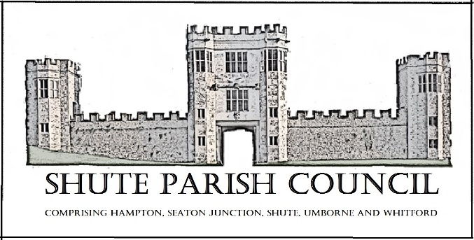
Colhayne Close, Colhayne Lane, Shute nr Axminster Devon, EX13 7QQ
Parish Clerk - Carol Miltenburg
tel:-01404 831080 e mail:-clerk@shute.eastdevon.gov.uk www.shuteparishcouncil.org.uk

The Councillors were summoned to attend a meeting Shute Parish Council held at Umborne Hall on Thursday April 21st, 2021 starting at 7.30pm, the Parish Council meeting to start immediately after the Annual Assembly of the Parish. The following matters were discussed. (The meeting started at 7.35pm).
Those present Cllrs Angela Choake, Paddy Magrane, Bill Marshall (Chair), Richard Orsman, David Plowman and Iain Chubb (EDDC & DCC) and Carol Miltenburg (Clerk). Apologies were received from Cllrs Ella Sweetland and Mary Thomas.

ANNUAL ASSEMBLY OF THE PARISH – MInutes

- Chairman’s report 2022.
Yet again a year affected by COVID. A t least we have been able to meet again many thanks to Whitford village hall initially for this and now we can use St Michaels and Umborne village hall is back in operation.
We must remember COVID is still present so can’t drop our guard. As Usual a big thank you to all our volunteer helpers and councillors, plus our continued support and guidance from Ian Chubb. Carol as always has been our mainstay, we could not function without her. Our quiet world in Shute has now played a small part in world events through the organisation of Ella in our practical contributions to help Ukraine following a very positive response by the community and much help given by one of our councillors Richard plus loads of other willing helpers. Yet again I appeal for more councillors, Whitford currently has a full complement but we are in need of two more councillors to provide a fuller representation of the parish, so please keep you eyes open for any likely candidates as personal contact with existing councillors is our most usual method.

- County/District Councillor’s report.
- Police report - None present.
- Public Forum – None present.

The meeting ended at 7.55pm

PARISH COUNCIL MEETING – Minutes

The meeting started at 7.55pm. Those present Cllrs Angela Choake, Paddy Magrane, Bill Marshall (Chair), Richard Orsman, David Plowman and Iain Chubb (EDDC & DCC) and Carol Miltenburg (Clerk).

- Apologies for absence were received from Cllrs Ella Sweetland and Mary Thomas. No declarations of interests were made.

- The minutes of the meeting of March 3rd 2022 were accepted by the Council and signed by the Chair.

- Matters arising from previous minutes. Stickers these were shown to the Council. Meeting venues – these have now been settled and the meeting in July will be at St Michaels. Parish Boundary Stone – the Clerk updated the Council with the concerns of damaging the stone and that a information board may be more appropriate. The Council approved the concept of an information board. Clerk to chase.

- Public Forum. None present.

- Reports from Councillors – Cllr Chubbs report is above. Police – no report received.

- Finance. Payments to be made DALC £152.61 subscription, ICCM £95 subscription, plus any others that may be required. Payments received – EDDC £2400.00 precept. The bank statements were available for viewing.

- Shute school – The Clerk is to arrange a meeting. A Tuesday afternoon was most suitable for the most Councillors. Burial Ground Cllr Choake and the Clerk met recently at the Ground and felt that they had found the most suitable spot for the apple tree to be planted. A date will be arranged shortly.

- Highway Matters. Cllr Plowman updated the Council on the improvements to Banks Close Lane, Whitford. The DCC PROW officer Emma Hellier has been very helpful to the Council and has done some really good work arranging for the potholes to be filled in so quickly and thus making the lane more usable for the residents. The Clerk advised about setting up a group of parishes affected by the A35.

- Planning. 22/0662/FUL - Rivermead Cottage, Whitford, EX13 7NR. The Council had no objections.

- Emergency Plan – Carried forward.

- Correspondence. None

- Any Other Business. Platinum Jubilee – The Clerk is still in correspondence with the National Trust about the possibility if planting of the Jubilee Oak near the Gatehouse in Shute. The planting will now take place in October. Cllr Choake advised the Council about the upcoming trip to Lundy (21 July) and Cllr Magrane spoke about the Lyme Crime talks (23-25 June). The Councillors will be given updated standing orders and financial regulations shortly. Cllr Orsman will inspect the noticeboard at the Gatehouse.

Date, place & time of next meeting:- May 19th Whitford Hall starting at 7.30pm. The Annual Meeting of the Council. The meeting where the Chair, Vice Chair and other posts are appointed.
.

Members of the public are more than welcome to attend our meetings.

