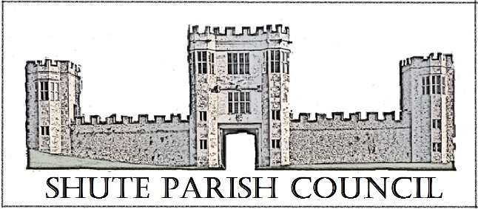

Colhayne Close, Colhayne Lane, Shute nr Axminster Devon, EX13 7QQ
Parish Clerk - Carol Miltenburg
tel:- 01404 831080 e mail:- clerk@shute.eastdevon.gov.uk

The Councillors were summoned to attend a meeting Shute Parish Council held at Umborne Hall on Thursday September 28th, 2017 starting at 7.30pm. The following matters were discussed.

Those present:- Cllrs Richard Orsman, Paddy Magrane, David Plowman, Ella Sweetland, Rick Wood and Cllr Ian Chubb (EDDC & DCC). Carol Miltenburg (Clerk) and 5 members of the public.

Minutes

- Apologies for absence were received from Cllrs Bill Marshall, John Pearce and Peter Rugg. No declarations of interests were made. In the absence of the Chairman and Vice Chairman, Cllr Rick Wood was unanimously elected as Chairman for the meeting.

- The minutes of the meeting of August 17th, 2017 were approved by the Council and signed by the Chairman.

- Matters arising from previous minutes. Dog poo bin. The Clerk is to obtain some stickers for the litter bin by the war memorial indicating that bags of dog poo can be placed in there. It was agreed to investigate sources of funding for a dedicated bin at Whitford Common the (approximate) cost would be £150 for the initial purchase and £200 per year for emptying. Clerk to investigate if the DCC Locality budget could be used. Cllrs Orsman and Plowman proposed, all agreed. Pride of Britain Awards. The Clerk was asked to nominate 2 more local residents for their work in the community.

- Public Forum – Those present wished to make their input in the planning section. The Chairman agreed to this.

- Finance. Payments to be made – Clerks salary £741.92; PAYE £2.40; R Warham (VAT) £10.00. Payments received EDDC 50% Precept. Proposed Cllr Sweetland, seconded Cllr Magrane.
The Pensions Regulator has acknowledged the Declaration of Compliance from the Council.
Donation request Ring & Ride – it was agreed to make a donation of £50.00. Proposed Cllr Wood seconded Cllr Magrane. The Council noted that in 2016 there were 176 return journeys to the parish and in 2017 (to end June) 101 journeys.
The Annual Audit of the Councils accounts has been signed off by the external auditors, Grant Thornton Llp, the Council noted their comments.

- Reports
There were no reports had been received from the Police. Cllr Chubb reported from EDDC and DCC. He advised he had recently met with Helen Selby our Highways officer and discussed the roads in the area. He reported that the waste and recycling collections had settled down and now 60% is recycled, EDDC have taken on extra trucks and workers to cope with the demand. The EDDC office relocation to Exmouth is due in mid-November with the now Honiton office due for December 2018. The appeal for the planning application at The Knowle in Sidmouth should be heard in November. There was a discussion of comparative parking charges in Lyme, Seaton and Axminster etc.

- Burial Ground update.
The Clerk updated the Council on the documentation. Cllr Marshall will update on the flowers/planting at the next meeting. It was felt the ashes area needs tidying. Clerk to contact Mr Wareham.

- Car Park. Cllr Plowman gave an update and showed the recent public presentation to the Council. He advised that the committee is awaiting documents from the owners land agent relating to the lease of land behind the school for use as a new playground and that the presently preferred site for the car park is in front of the school.

- Planning
17/1821/COU – Land opposite Shute Garage. The Applicants attended the meeting and answered questions from members of the public and the Council. The Council noted the comments made.
The Parish Council felt they cannot support this application.
Whilst always liking to support business in the parish, the Parish Council has always felt that the major problem with this particular site is the access, which is onto the A35 and has consistently voiced this concern with previous applications. The site located directly on a staggered junction with the additional distractions of vehicles at Shute Garage, as well as those turning into Starbucks (previously the Little Chef). With the number of possible vehicles bringing and taking dogs there will be a relatively high flow of traffic on and off the site almost inevitably at peak times. That those turning into the kennel entrance from Honiton would directly impede vehicles attempting to turn towards Shute and Colyton, leading to potentially dangerous accidents. The council would recommend re-routing access to the proposed kennels from the Shute Road to avoid potential conflict points on the A35. The Council also noted that there were concerns from local residents about noise.

DCC/4014/2017 Shute School. The Council supported this application.

17/2237/mful (adjoining parish) The Council noted the application and no objections were voiced.

- Correspondence received. The Clerk circulated the information sheet from the Blackdown Hills Parish Network concerning fast broadband in the area.

- Highway Matters. DCC highways conference the e mail from DCC was noted, more information to follow. The Clerk read out the e mail response from DCC Highways concerning hedge trimming, the Council noted this. The Clerk reported that our Highways officer is going to look at the potholes in Haddon Road. It was reported that the ‘Seaton Junction’ sign is obscured by undergrowth – Clerk to contact DCC.

- Any Other Business. It was reported that a youth (under 16) had been seen riding a small motorbike in Shute without a helmet. Clerk to report to the PCSO. Cllr Marshall will lay the wreath on Remembrance Sunday.

Date, time & place of next meeting:- Thursday, November 9th at Shute School starting at 7.30pm

The meeting concluded at 9.30pm

