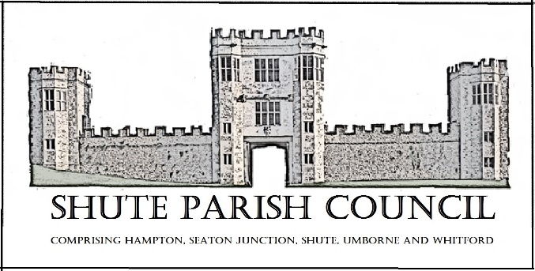

Colhayne Close, Colhayne Lane, Shute nr Axminster Devon, EX13 7QQ
Parish Clerk - Carol Miltenburg
tel:- 01404 831080 e mail:- clerk@shute.eastdevon.gov.uk www.shuteparishcouncil.org.uk

The Councillors were summoned to attend the first meeting of the new Shute Parish Council held at Whitford Hall on Thursday May 9th, 2019 starting at 7.30pm. The following matters were discussed.

Those present:- Angela Choake, Paddy Magrane, Bill Marshall, Richard Orsman, David Plowman, Ella Sweetland. Mary Thomas was unable to attend and sent her apologises.
Minutes

- Election of the Chairman of the Council – Cllr Bill Marshall was proposed by David Plowman and seconded by Richard Orsman. Election of Vice-Chairman of the Council – Cllr Ella Sweetland was proposed by David Plowman and seconded by Richard Orsman. These were unanimously agreed by the Council. Cllr Marshall signed the Chairmans acceptance of office.

- All the Councillors present delivered their acceptance of office forms to the Clerk.

- Co Option of new Councillors. Cllr Orsman proposed that Paddy Magrane be co-opted as a member of the Council, this was seconded by Cllr Sweetland and unanimously agreed. Cllr Magrane delivered his acceptance of office form.

- The minutes of the April meeting of the Council were accepted by the council and
were signed by the Chairman.

- All Councillors present delivered their General Notice of Registerable Interests from to the Clerk.

- The Council reviewed of the terms of reference for committees and appointment of members to existing committees. The following was agreed:-

Whitford Village Hall Committee – Cllr Marshall
Hitchcock Trust - Cllr Orsman & Carol Miltenburg
Burial Ground Committee – Cllrs Orsman. Choake & Sweetland and Carol Miltenburg
Car Park – Cllr Plowman

- Appointment of any new committees etc. Footpath Warden – Cllr Orsman. It was agreed for the Clerk to place an advert in the parish newspaper and news e mail to ask for volunteers to report on the paths in the Parish.

- The Council reviewed the proposed standing orders, financial regulations and code of conduct. The Council unanimously agreed to adopt the above documents. Proposed Cllr Marshall, seconded Cllrs Magrane and Orsman.

- The Council reviewed of representation on or work with external bodies and arrangements for reporting back. It was agreed that reports would be given in the relevant section at meetings of the Council. The Council will continue to be in contact with the Police to obtain reports.

- The Council reviewed the inventory of land and assets including buildings and office equipment. It was agreed for the Clerk to get a quote to replace the noticeboard at the Whitford Hall and also ask Mr Pike for a quote to repair the noticeboard at St Michaels.

- The arrangements for insurance cover in respect of all insured risks were reviewed and are due to be renewed shortly. It was unanimously agreed that these were adequate. The quote from Came & Co for the renewal of the policy was unanimously accepted. Proposed Cllr Marshall, seconded Cllr Magrane.

- The council’s and/or staff subscriptions to other bodies were reviewed. These are the Inst of Cemetery and Crematorium Management and the Devon Assn of Local Councils. Proposed Cllr Marshall, seconded Cllr Orsman.

- Review of the council’s procedures for handling requests made under the Freedom of Information Act 2000 and the Data Protection Act 1998 and the council’s policy for dealing with the press/media. It was agreed that these will be dealt with as per the standing orders.

- Matters arising from previous minutes. The telephone kiosk was discussed and it was felt that it has always been agreed that it would be located at Shute, so would not be available for the Umborne Hall.

- Public For/um. None attended

- Finance. Payments to be made:- Came & Co £294.17 (Insurance) Payments received:- EDDC £2400.00 (precept), Kilmington PC £140.00 (re Hitchcock Trust insurance). The bank statements were available for viewing.
Annual accounts / audit. The Chairman and Council reviewed the Annual Audit. The Chairman signed the Certificate of Exemption. The Annual Governance Statement was read to the Council by the Chairman. All items were agreed and the Chairman signed the statement. The Council reviewed the Accounting Statements. These were approved by the Council and the Chairman signed the statement. The Clerk provided explanations for the exceptions which were accepted by the Council.
The Bank account mandate was amended to remove previous Council members and add new members of the Council.

- Burial Ground. Wall quote – Clerk to chase (again) for the quote for repairs. Burial Ground book – Clerk to give the approval to the proof copies supplied by the printer.

- Car Park / Shute School. Cllr Plowman advised there is no update. It was commented on that the pupil numbers have reduced and that this together with the use of traffic cones is easing the parking problem.

- Highway Matters. It was noted that the verge on Shute Road need cutting. The Council discussed the recent accident on the A35, the road was closed for a number of hours. The sheer volume of traffic diverted from and avoiding the road closure caused considerable disruption in Whitford and Haddon Road in Shute. The Council felt that whilst the traffic has to be diverted off the A35 in cases like this some thought should be put into the roads used and Cllr Marshal will discuss this with PCSO Bolsover. Clerk to remind our Road Warden (Richard Brain) about a pothole by Highbank, Whitford, some in Shalford Terrace and the state of Coxley Lane in Umborne.

- Planning. 19/0970/FUL – Colcombe Wood, Colyton, swimming pool etc. The Council had no objections to this application.

- Emergency Planning – carried over to next meeting.

- Correspondence. Community survey report (churches in Shute) this report was noted.

- Any Other Business

Date, place & time of next meeting:- June 27th, 2019 at Shute School starting at 7.30pm.

The meeting ended at 9.10pm.

